Introduction

* Known as
  + Neural Networks (NNs) 🡪 fined-grained, parallel, distributed, computing model
  + Artificial Neural Networks (ANNs)
  + Connectionist Models
  + Parallel Distributed Processing (PDP) Models
* NNs are inspired by brain
  + Knowledge is acquired experientially (learning)
  + Knowledge stored in connections (weights)
* Brain composed of neurons
  + Dendrites collect input from ~104 other neurons
  + Axon sends output to other neurons
  + Connected at synapses that have varying strength
  + This model is greatly simplified

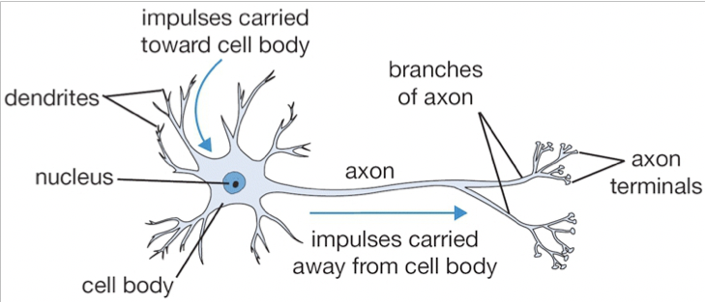

* + Ex. Recognizing Digits using a Neural Net
  + 🡪 recognizing digits using a neural network as a classifier

Strengths of NN Approach

* Massively parallel
  + From a large collection of simple processing elements emerge complex, global behavior
* Can do complex tasks
  + Pattern recognition (handwriting, facial expressions)
  + Forecasting stock prices, power grid demand)
  + Adaptive control (autonomous vehicle control, robot control)
* Robust computation
  + Can handle noisy and incomplete data due to fine-grained, distributed and continuous knowledge representation
* Fault tolerant
  + Ok to have faulty elements and bad connections
  + Isn’t dependent on a fixed set of elements and connections
* Degrades gracefully
  + Continues to function, possibly at a lower level of performance, when portions of the network are faulty
* Uses inductive learning
  + Useful for a wide variety of high-performance apps

Neural Network Architecture

* Large number of units
  + Simple neural-like processing elements
* Connected by a large number of links
  + Directed from one unit to another
* A weight associated with each link
  + Positive or negative real values
  + Means of long-term storage
  + Adjusted by learning
* An activation function associated with each unit
  + Result of the unit’s processing
  + Unit’s output